Is the covid test still required?
Yes
For the covid test, how recent should it be done in relation to the trip and is there a specific type of test that is preferred?
2 days max before the trip. No preference for test.
Could you go over RA's of the observable objects in class? I had a hard time understanding that part of the document.
This is done week 2, but right ascension is a way to denote how far something west or east is along the night sky. Its like longitude. Only half of the sky is visible at a given moment at night so 180 degrees or only 12 hours. As Earth orbits the sun the portion of the night observed also shifts so
If we do get covid before our observation night, will we still be able to go up to the telescope on another day?
If there is space/time maybe.
This might be obvious/already heavily implied, but just for clarity, are we the ones picking the specific target for each project description or are there already a few targets in mind for each listed project (ie the exoplanet transit)
For exoplanet transit, I (Dr. Miles) let students pick their target. There are online tools to pick good candidates and tell you when a transit will occur. Last semester the students picked great targets.
For the M33 project, you only point at M33. For the supernova projects, I suspect Dr. Milne or another colleague will have a list of potential targets.

Would accessibility be an issue at the telescopes? I cannot stand/walk for more than a few minutes at a time, and can only take stairs if I have somewhere to sit later.
Ideas so far from Dr. Milne
61)
a) For the most part, students do not venture down to the dorm. I have been present when students went down for dinner, but other groups have stayed up in the control room. I think that we organize that group to stay in the control room. Even if weather delays our start, we can stay in the control room.
b) Moving between the control room and the dome does require heading up the stairs. I agree that we should make sure that there is a chair available in the dome. I might also have a few camp chairs in my truck to make sure that all students have a chair available. An alternative would be to coordinate with mtnops, but if I bring chairs, we know that we are set.
90)
a) there is an elevator at the 90" that moves between all floors. It is an odd, flaky elevator, but as long as we follow the procedures, we can reach all floors without stairs.
b) I will contact mtnops to see if we can guarantee additional chairs in storage to make sure everyone can sit. That was an issue in the past, so I'd like to solve that in any case. I might bring camp chairs to be certain. Worst case, super-LOTIS has 2 chairs that we can access to be 100% certain to have chairs.

What is on-chip binning? The section about the 61" Kuiper imager mentions it and I've never heard the term before.
You combine the information from an area of 2 x 2 pixels

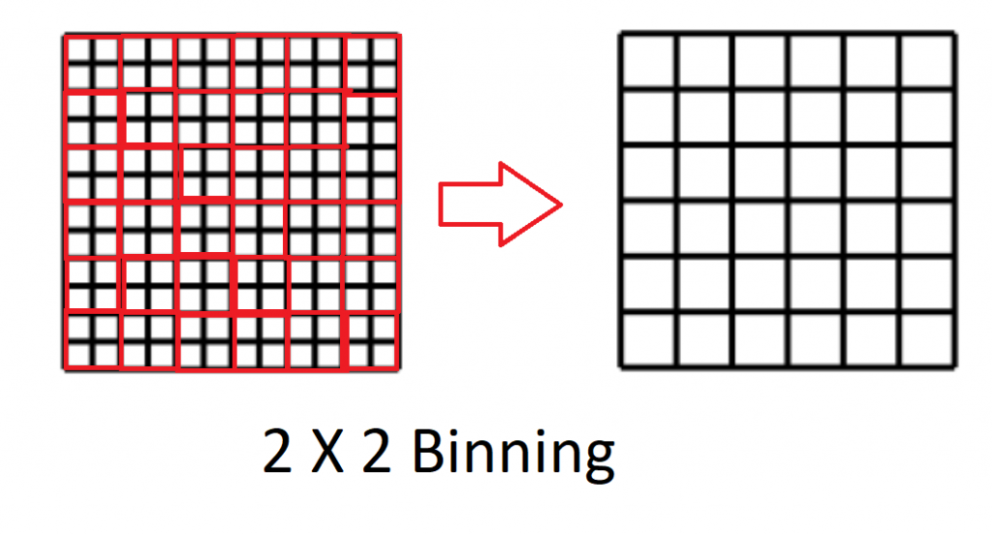

How will we determine which telescope to use for our target if there is availability for both?
If you can do your science on a smaller telescope you should. If you need to do spectroscopy you cannot do it on the Kuiper telescope because we only have an imager on it.
What happens if a teammate becomes uncooperative or ghosts the project?
One of your instructors or TAs will check in each Friday to understand how group work is going after observations occur in attempt to make sure that complete ghosting does not happen.
If a group member is late to a presentation, they are individually docked points for it.
How many hours a week should we expect to go towards working on the project.
A couple hours per week minimum after observing. Students typically have to reduce the data multiple times to verify that reductions are reasonable. The last month of the semester one day a week is dedicated to project work in class.
Since rescheduling isn't possible this year, if our group's telescope night gets weathered out and we're unable to obtain any data, will there be any adjustment to the grading criteria or expectations for our final project?
An observer will take data for your project later in the semester or later that weekend. If nothing works and you get no new data you need to use archival data.
What different kinds of data do the telescopes take exactly? How can we read and understand it?
The instruments behind telescopes record

On the planned times do we (the group) get all of those days, or just one to collect data?
Historically one night.

Wouldn't using different sized telecopes affect the data the groups get?

Yes but you can estimate how it will impact data quality.
If an overnight stay at the telescope is required, will showers be available to us?
Yes but it is a communal bathroom.

Regarding the part about "providing a screenshot of your negative Covid test result on your phone", does that mean we need to do this 15 days on Campus Health before the observation date?

Based on information such as, "It's important for each group to try to obtain their data as early in the semester as possible," and "If you have an idea for a project that requires imaging data, we can help you determine if it's feasible to obtain the necessary observations using the 61" Mont4k camera," it seems like the course requires us to decide on a final project immediately. However, from what I gathered in the first class, many people don't have any observational experience before. Without enough time to dig into the field, how should we decide which topic to choose, even though the guide mentioned that the teaching team could suggest project topic ideas that have worked well in the past?

Will our project only get one night of observing each? If the weather is poor how will we account for that?

If TA or instructor gets sick the observing schedule basically falls apart, so in this case should we focus on a backup project with archival data?

What nights will allow for observations of an exoplanet transit?

What level of weather is considered to interfere with relative magnitude projects as opposed to absolute magnitude?

How much prior observation experience are we expected to have, besides the knowledge provided through the D2L documents? In addition, how will the data collected during the observations be provided to us?

Will we need to get our own COVID tests before observing or will they be provided?
Could we bring our own telescopes with us on observing nights to use before/between/after observations?

My question is, assuming we had a successful observation, how are we expected to obtain the data from the telescope afterwards and how quickly can we get it? Also related, how large could we expect some of the datasets to be?
KB for time series it can be larger 1G

How ambitious should the projects be? What can be considered a "good" dataset, given the limited observing time? Should we have alternate plans in case the observation fails?

I'm confused about "Landolt standard stars" could you explain it more?
Also, is there any added precaution to be had with the secondary mirror of the 61"? I know it almost fell out over the summer.

How do we decide which observing telescope is best for the project we choose？

How will we determine which telescope to use for our target if there is availability for both?

